Table of Contents
Introduction 2
Application Registration on Azure 2
Step 1 : App Registration >> Create New Application 2
Step 2> Keep a note of Client ID, Tenant ID along with Endpoints required for this POC 2
Step 3> Providing Access to the Application for Azure Vault Service 3
Step 4> Create a secret for the Application. 4
Step 5> Click a Resource Group >> create Key Vault 6
Step 6> Copy the vault Name and Vault URL 7
Step 7> Provide access to the Application to the key Vault 7
Step 8 >> Create a secret in Key Vault 9
POSTMAN testing of Key Vault API 11
Step 1> Setup environment variables (Better approach) 11
Step 2> Select the environment >> Configure Postman GET operation to hit Vault 12
Step 3> Hit Azure Vault – With No Token 13
Step 4> Retrieval of Token 13

Introduction
Below are simple ways by which a Key Vault and all pre-requisites could be retrieved in order to use Azure Key Vault REST APIs to retrieve Secrets.

Application Registration on Azure

**** Please note that the app client id and secret will no longer work as its already been deleted ***

Step 1 : App Registration >> Create New Application

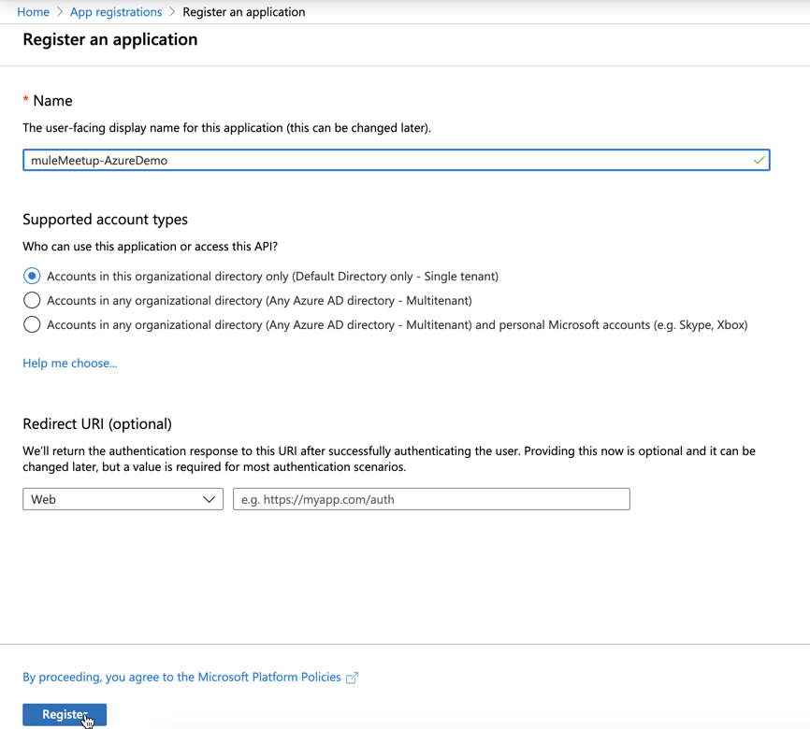

Step 2> Keep a note of Client ID, Tenant ID along with Endpoints required for this POC

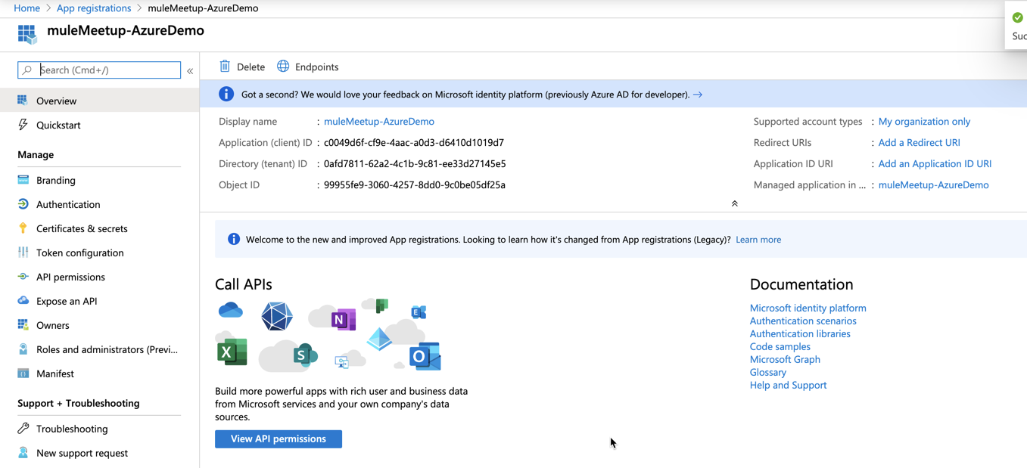

In this case:
Client ID, Tenant ID, Endpoint URL to authenticate against Azure Cloud for the org.

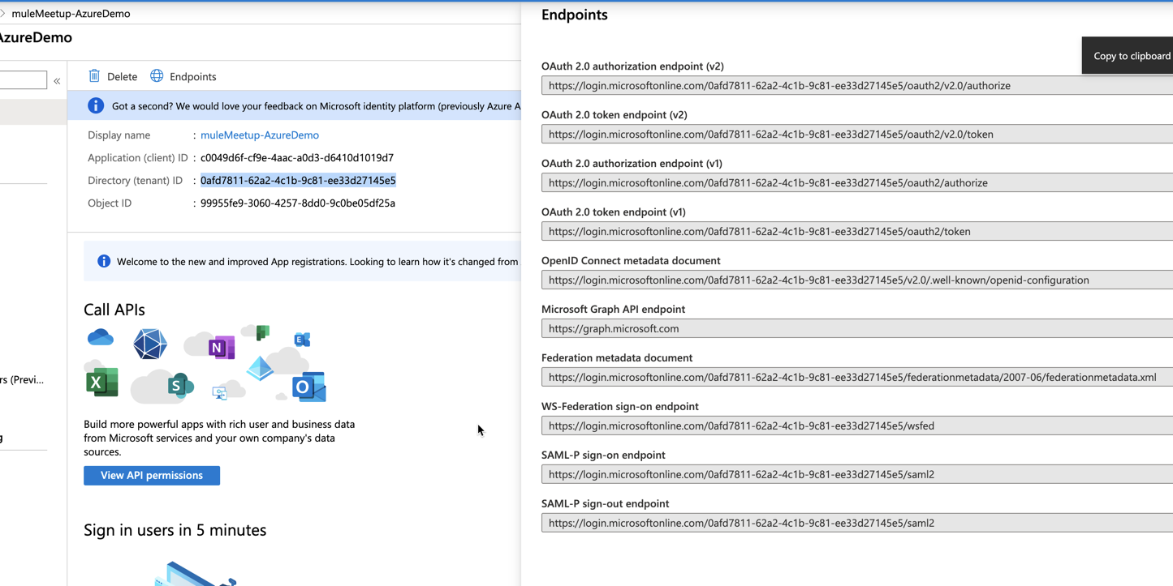

Note: Endpoint Which we would use : https://login.microsoftonline.com/0afd7811-62a2-4c1b-9c81-ee33d27145e5/oauth2/token

Step 3> Providing Access to the Application for Azure Vault Service

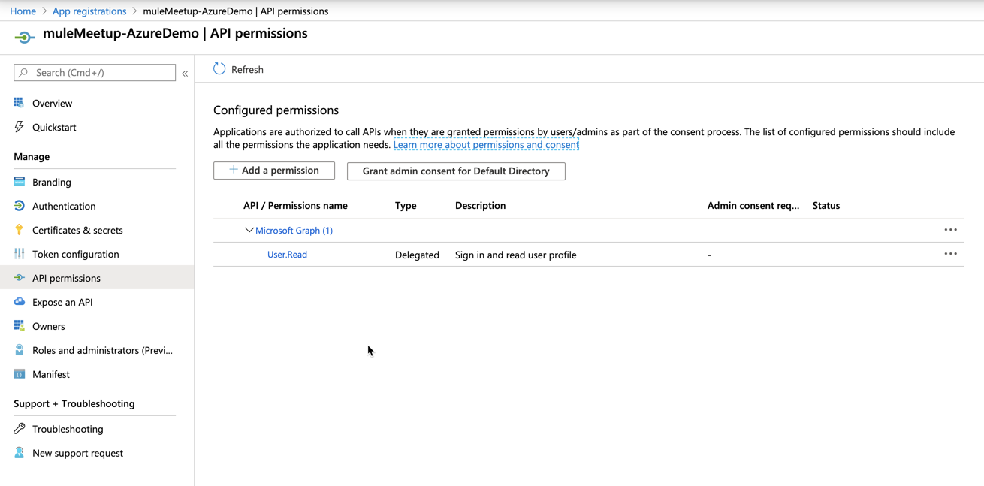
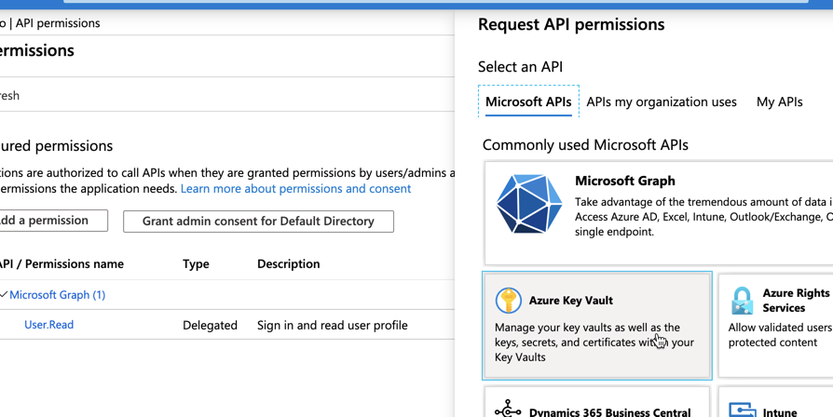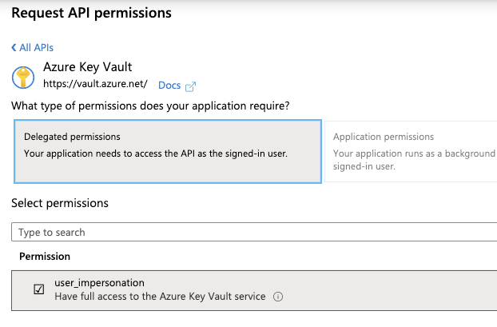

Step 4> Create a secret for the Application.
This is the client Secret to be used for the application.

Certificates & Secrets

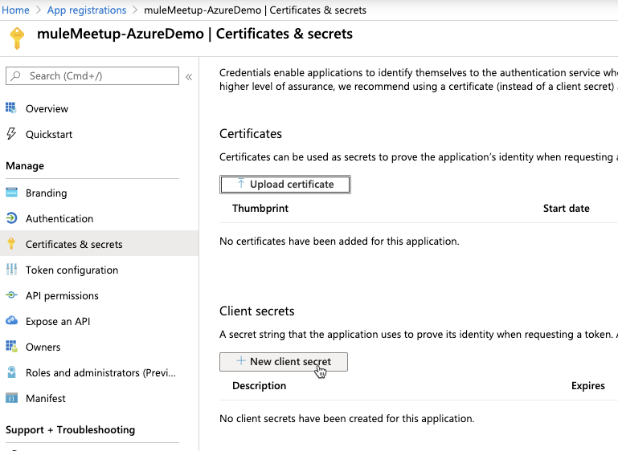

Provide a description and Expiry to the Client Secret.

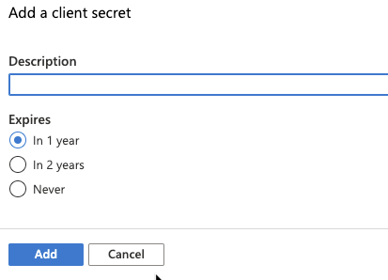

Copy the client secret
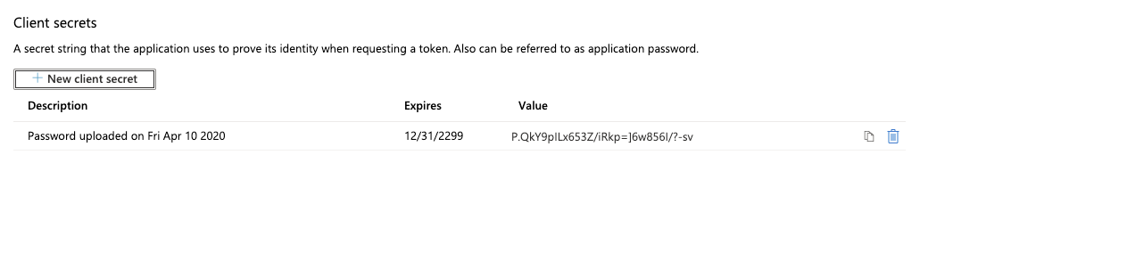

Step 5> Click a Resource Group >> create Key Vault
This will be used to classify the Key Vaults.

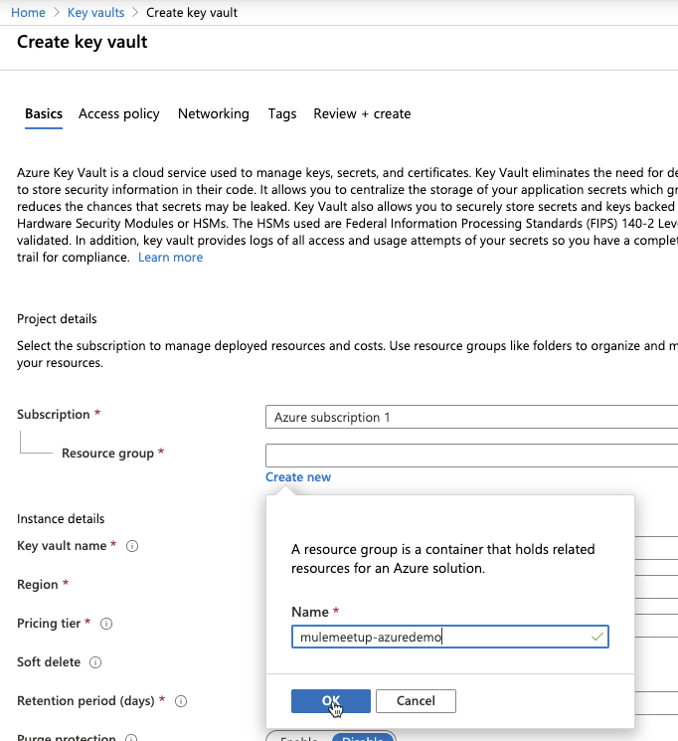

Key Vault Name creation

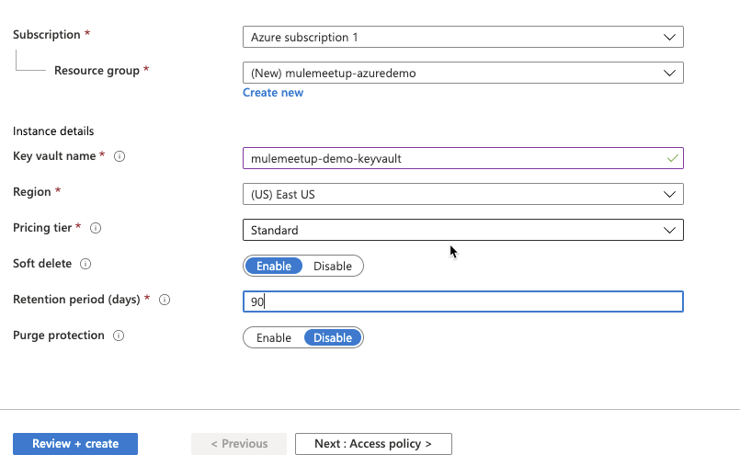

Review and Create >> Create

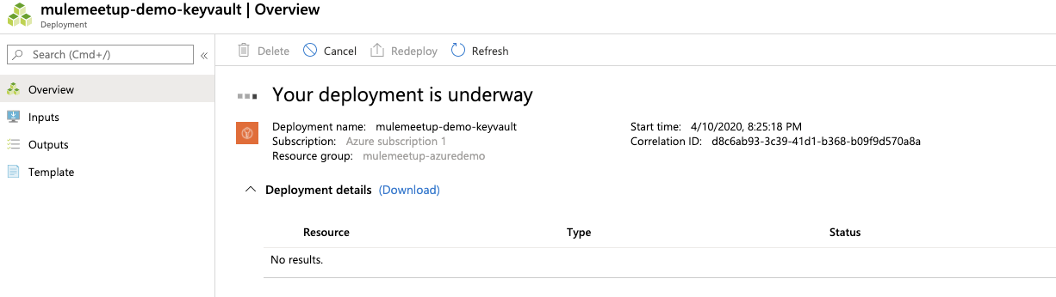

Step 6> Copy the vault Name and Vault URL
DNS Name: https://mulemeetup-demo-keyvault.vault.azure.net/
Vault Name: mulemeetup-demo-keyvault (All lower case)

Step 7> Provide access to the Application to the key Vault

This has to be done within Access policies from Key Vault >>> Add Access Policy

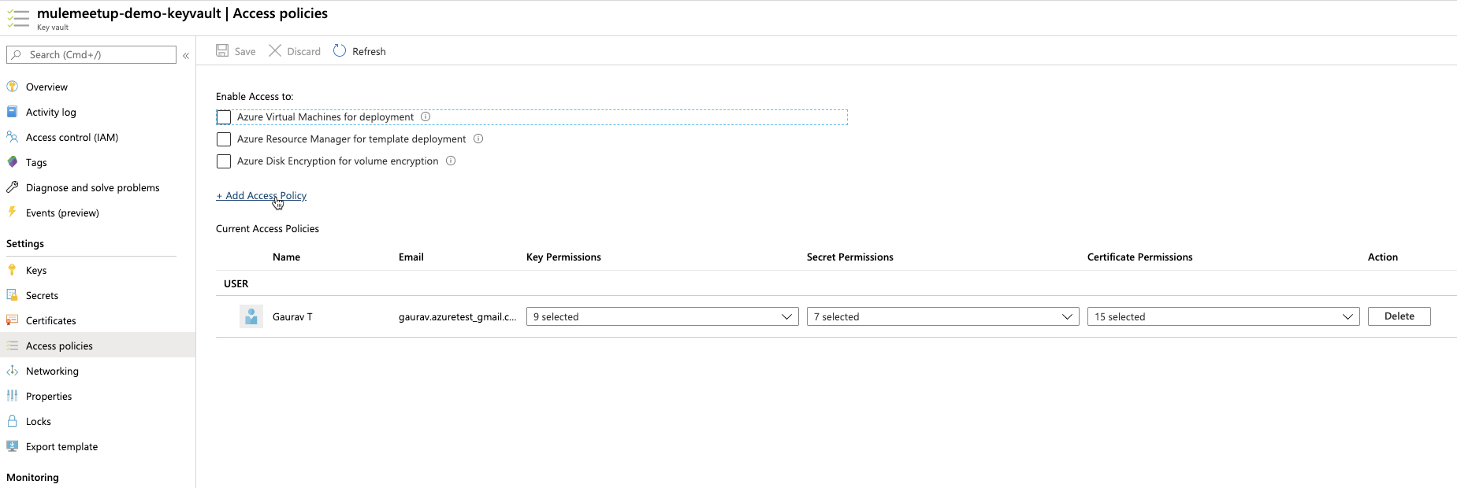

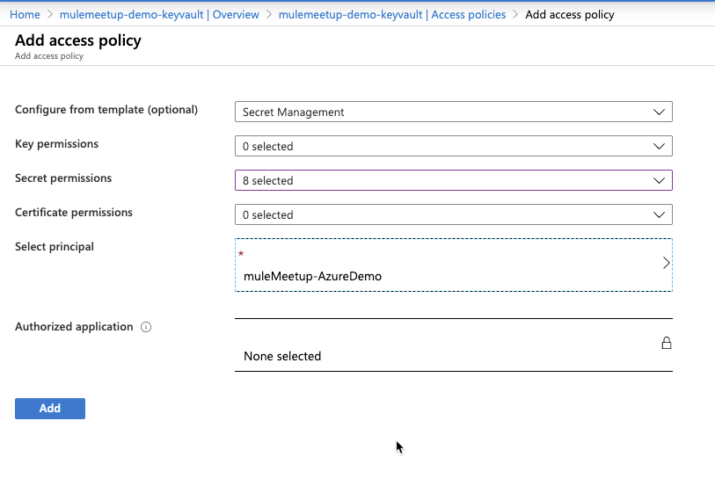
Note: Note that Selecting Principal is mandatory and this is where you will select the Application which you created on previous steps

>>>> SAVE

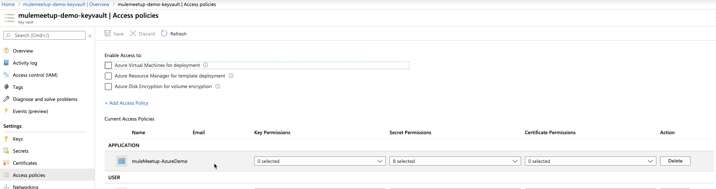

Step 8 >> Create a secret in Key Vault

Secrets are kept under “Secrets”

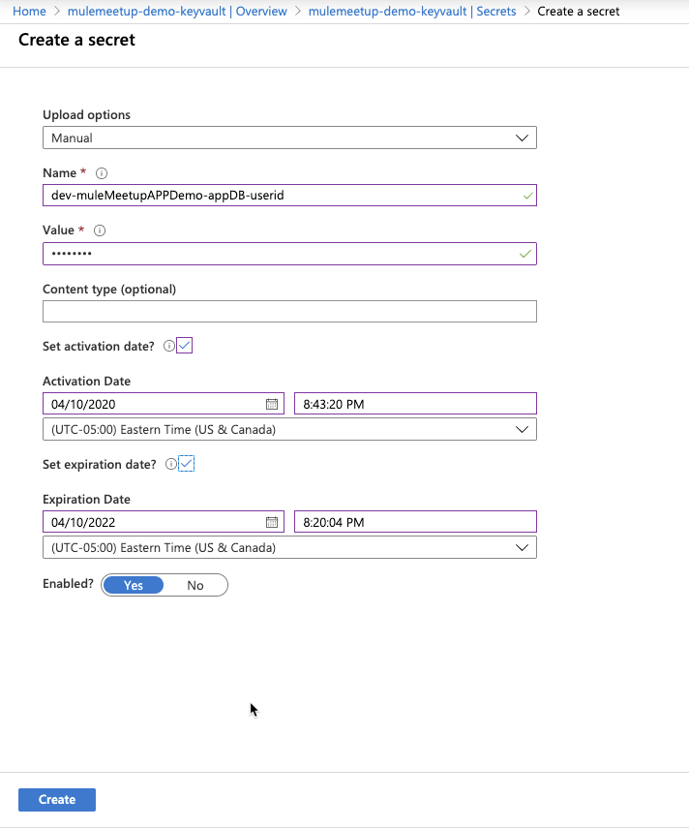

POSTMAN testing of Key Vault API

Step 1> Setup environment variables (Better approach)

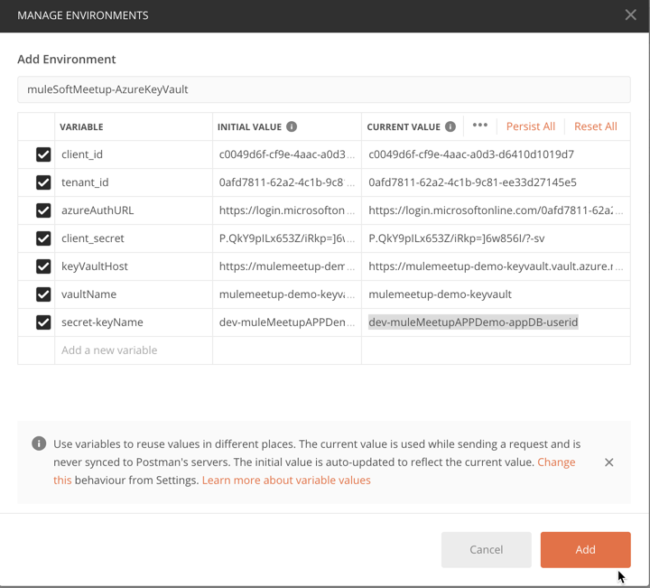

Step 2> Select the environment >> Configure Postman GET operation to hit Vault
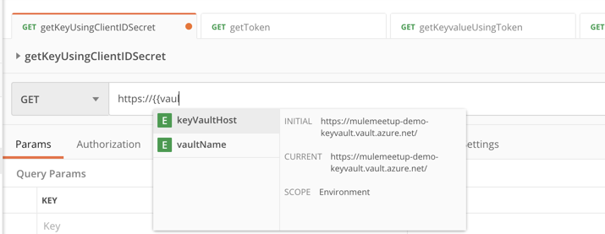

Note:
Easy method to retrieve a single key : Copy the URL directly from Key Vault for the secret

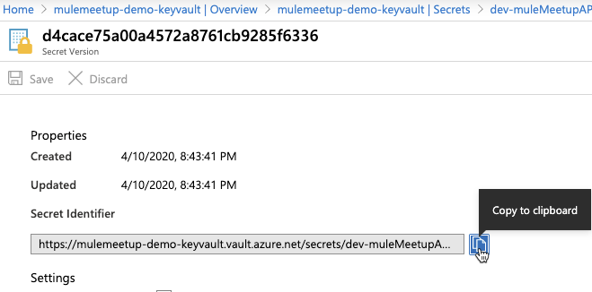

https://mulemeetup-demo-keyvault.vault.azure.net/secrets/dev-muleMeetupAPPDemo-appDB-userid/d4cace75a00a4572a8761cb9285f6336

If you want to always retrieve the latest version of the secret Value, use this instead

https://mulemeetup-demo-keyvault.vault.azure.net/secrets/dev-muleMeetupAPPDemo-appDB-userid/?api-version=2016-10-01
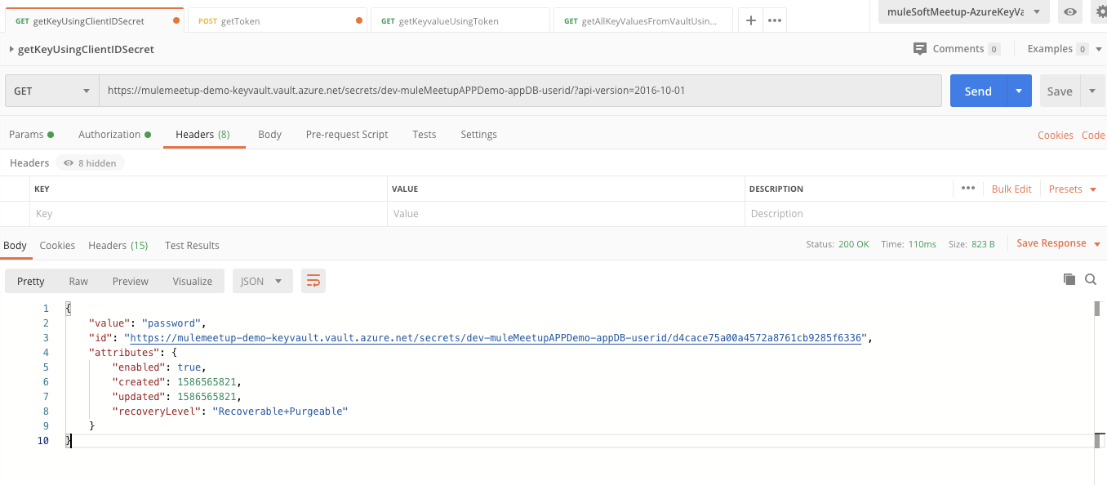

Step 3> Hit Azure Vault – With No Token

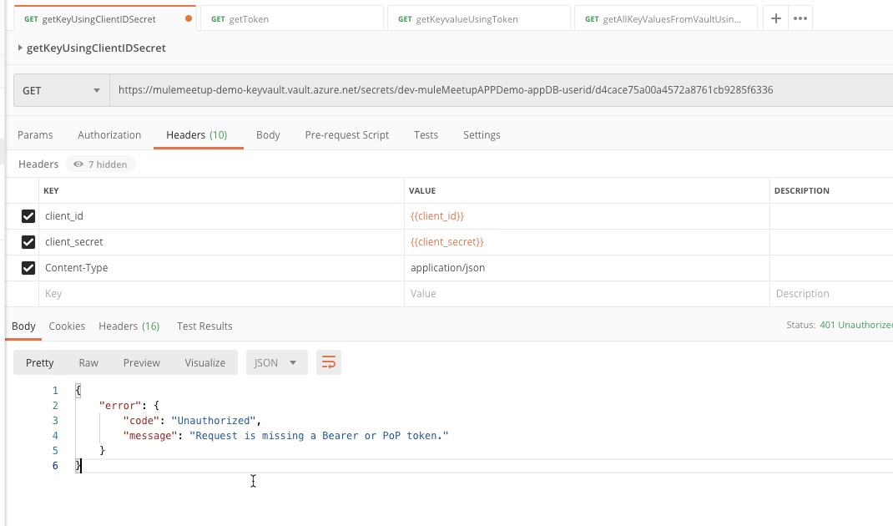

Step 4> Retrieval of Token

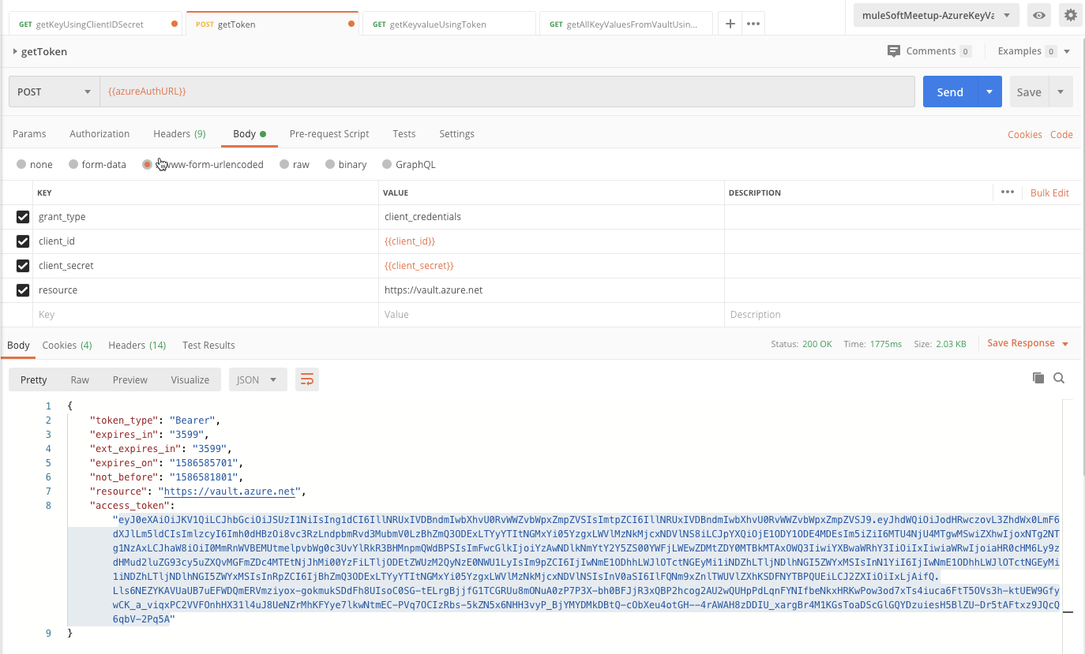

Note: Below will be the error when the token is created without the Vault as the Resource Type

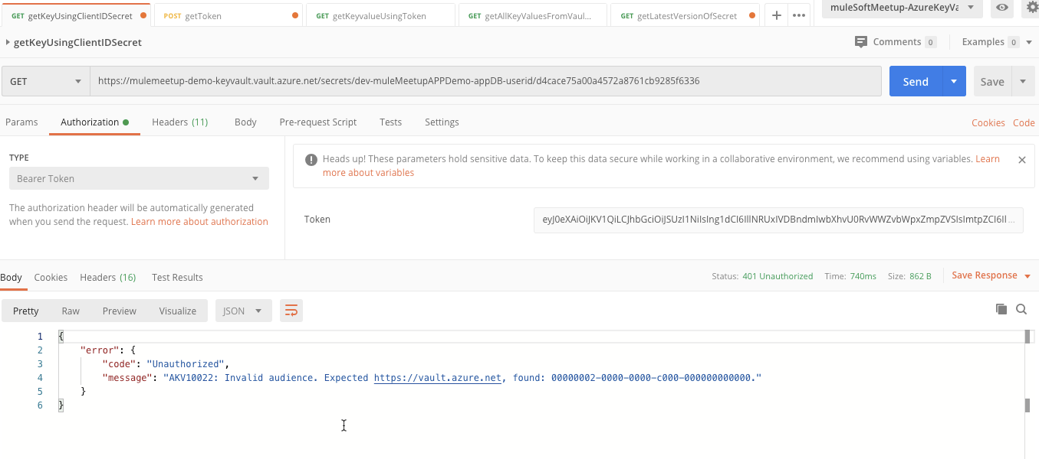

Now the final step would be to copy the access_token and hit Azure Key Vault REST API successfully.

